5.3 Exponential Functions and Models

Comparing Linear and Exponential Functions

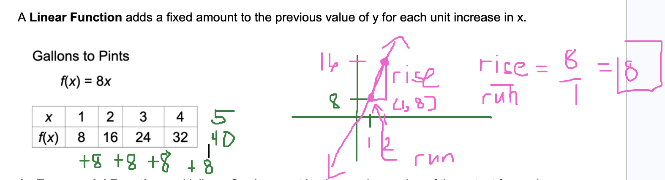

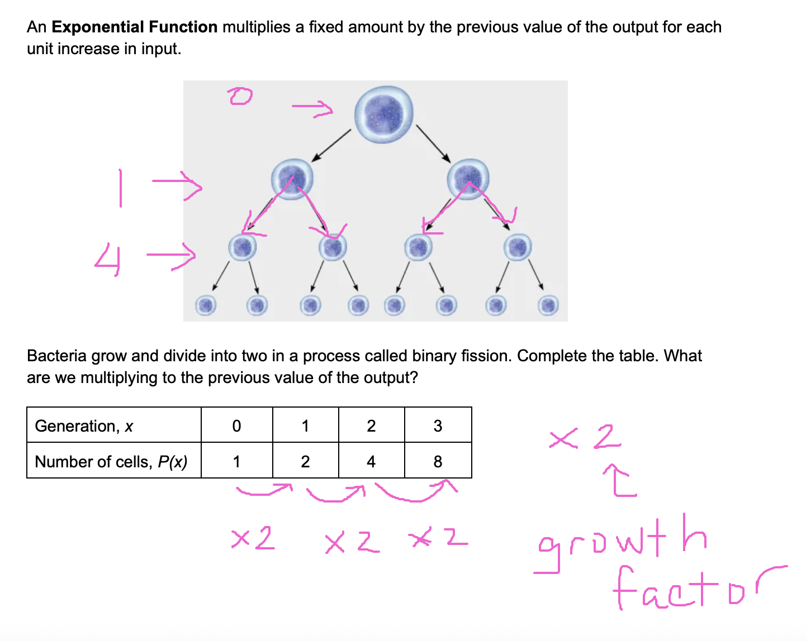

Exponential Functions
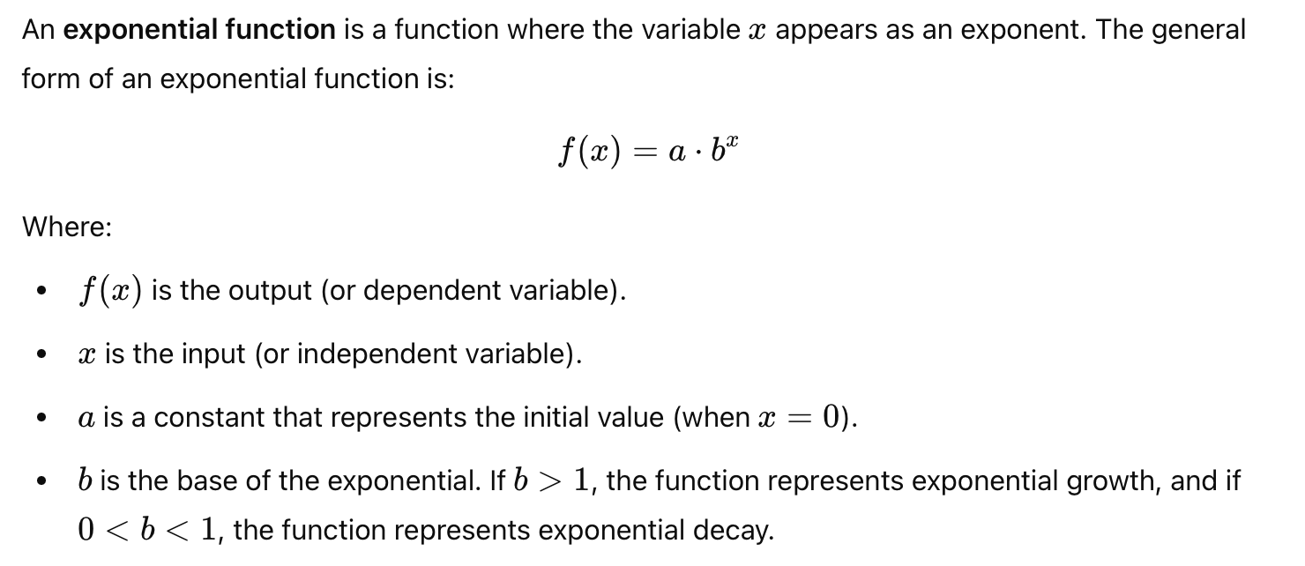

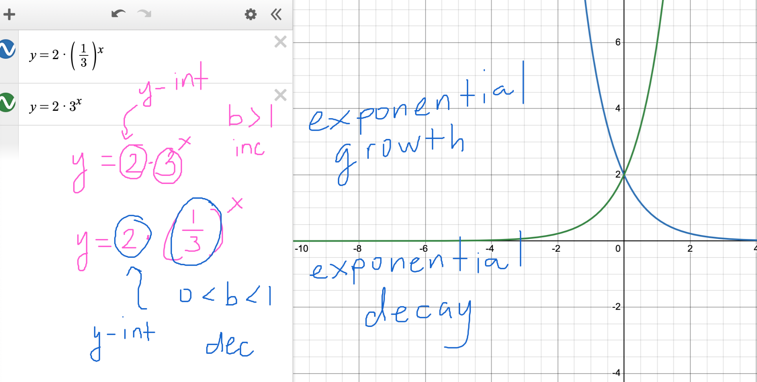

Example

- A population of 500 bacteria doubles every 3 hours. How many bacteria will there be after 12 hours?

$f(x) = a⋅b^{x}$
a - y-intercept (initial value)
a = 500
x is the number of hours

$f(x)=500⋅2^{x}$ (INCORRECT)
$f(3) = 500⋅2^{3}=500(8) = 4000$ (After x = 3 hours, we'll have 4000 bacteria, but this is not what the table says, so $f(x)=500⋅2^{x}$ is not correct).

x | 0 | 3 | 6 | 9 | 12
f(x) | 500 | 1000 | 2000 | 4000 | 8000

Question: Find the correct equation for f(x).

ATTEMPT:
$f(x)=500⋅1.26^{x}$
$f(3) = 500⋅1.26^{3}=1000.188$
VERY GOOD ATTEMPT

$f(x)=500 ⋅2^{x/3}=500⋅(2^{1/3})^{x}$

- A car's value decreases by 15% per year. If the car is initially worth $20,000, what is its value after 5 years?

a = 20000

x | 0 | 1 | 2 | 3 | 4 | 5 | 6
f(x) | 20000 | 17000 | 14450 | 12282.5 | 10440.13 | 8874.11

20000 - 20000*0.15 = 20000(1 - 0.15) = 20000*0.85

$f(x)=a ⋅b^{x}=20000 ⋅0.85^{x}$
$f(x) = 20000⋅0.85^{x}$
$f(5) = 20000 ⋅0.85^{5}=8874.1$1

Example:
30% OFF!!!!!
T-Shirt $40
How much are you supposed to pay before tax?
40*0.30 = 12, 40 - 12 = 28
40 - 40*0.30 = 40(1 - 0.30) = 40*0.70

Compound Interest
Compound interest is the interest on a loan or investment that is calculated not only on the initial principal (the original amount of money), but also on the accumulated interest from previous periods. This means that each period's interest is added to the principal, and in subsequent periods, interest is calculated on the new total (principal + previously accumulated interest).
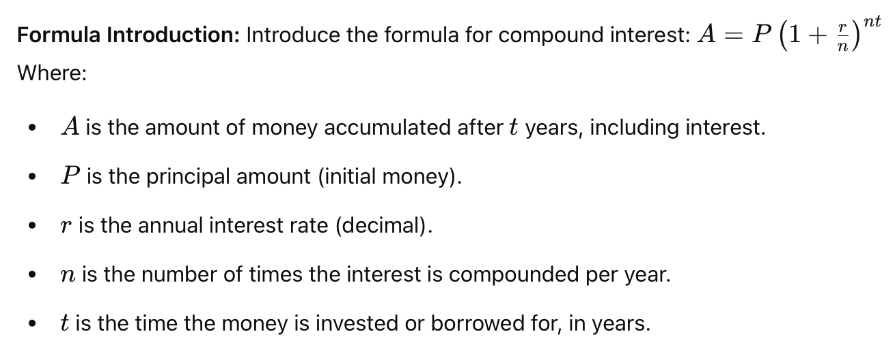

Example Comparing Compound Interest
Suppose $1000 is deposited by a 20-year-old worker in an Individual Retirement Account (IRA) that pays an annual interest rate of 12%. Describe the effect on the balance after 45 years at age 65 if interest were compounded quarterly rather than annually.

Continuous Compounding

Compounding that is done more frequently, by letting n become large without bound, is called continuous compounding.

The formula uses euler's number, e ≈ 2.71828182846.

Formula for Continuous Compounding

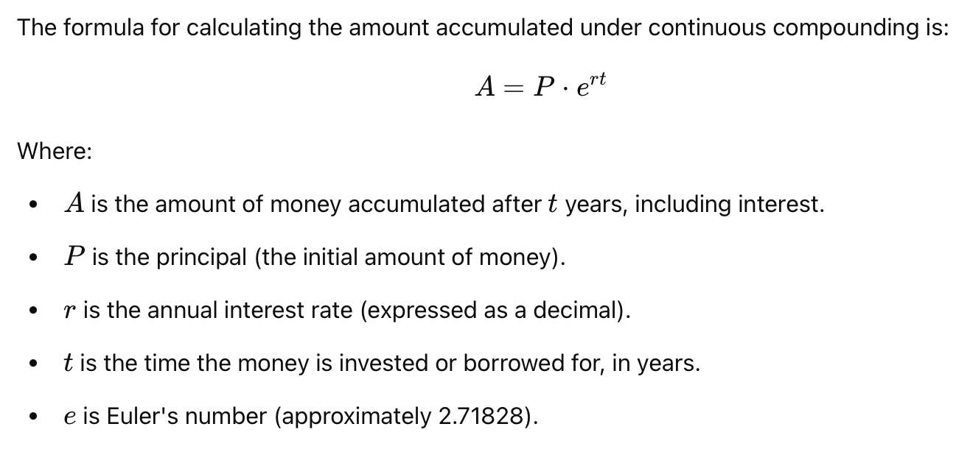Example

The principal in an IRA is $1000 and the interest rate is 12%, compounded continuously. How much money will there be after 45 years?

